Level 7 Assignment #2 Due no later than January 30, 2027

Research Essay on our Patron St. Anthony of Padua
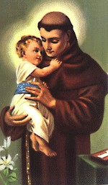
∼
St. Anthony of Padua is the patron saint of our parish. Learning about the life of this great saint will help you grow in your own faith as you continue your preparations for the sacrament of Confirmation. Students are encouraged to use several sources to research St. Anthony and then compose a one-page essay in their own words. Students should include biographical background on St. Anthony (when and where he was born, important milestones in his life, etc.), as well as information on how St. Anthony’s relationship with God evolved throughout the course of his life. Finally, what aspects of this saint’s life do you relate to as a teenager in today’s world?

Important reminder: plagiarism will not be tolerated. This essay must be in the student’s own words.

Students should complete and turn in this assignment to their catechist at Religious Education class, or directly to the Religious Education Office, no later than January 30, 2027.

Level 7 Assignment #2

NAME: DATE:

Research Essay

